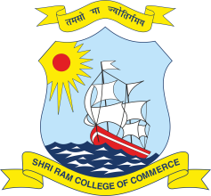 | SHRI RAM COLLEGE OF COMMERCE  University of Delhi, Maurice Nagar, Delhi – 110 007  Website: www.srcc.edu Phone: 27667905, 27666519

Date: 17.07.2020

BID OPENING SCHEDULE

S. No. | Project Name | Bid Opening Date | Bid Opening Time
1 | Rectification of Electrical Works in New Girls Hostel | 20.07.2020 | 12:30 P.M.
2 | Replacement of Old Rusted and Damaged Water Supply Pipe Lines  (Project-1)  (From Maurice Nagar Crossing & Patel Chest Side) | 20.07.2020 | 01:00 P.M.
3 | Replacement of Old Rusted and Damaged Water Supply Pipe Lines  (Project-2)  (Through Daulat Ram College Side) | 20.07.2020 | 01:30 P.M.

Bid Opening Venue
Committee Room, Shri Ram College of Commerce, Delhi – 110 007

The Bidders are advised to remain available at the venue half an hour before opening Bids and participate in the Bid Opening Process as per above schedule.

PRINCIPAL

